Practical 3
AIM:-Using tracert, ping, ipconfig, netstat Command
Step 1: Type tracert command and type www.prestashop press “Enter”.
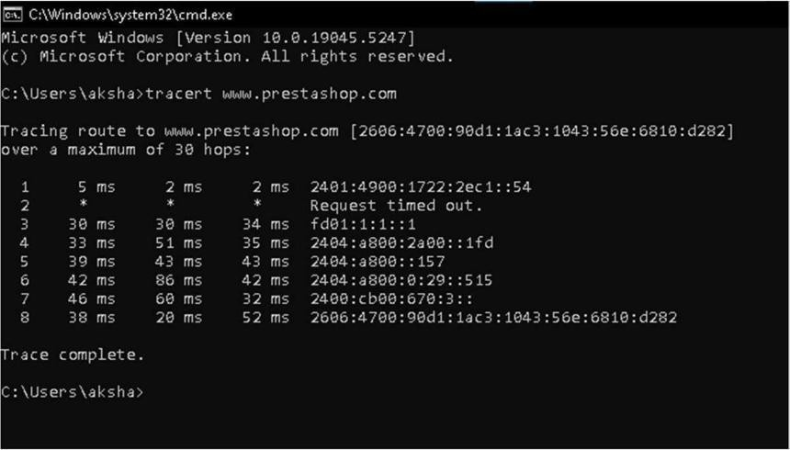

Step 2: Ping all the IP addresses
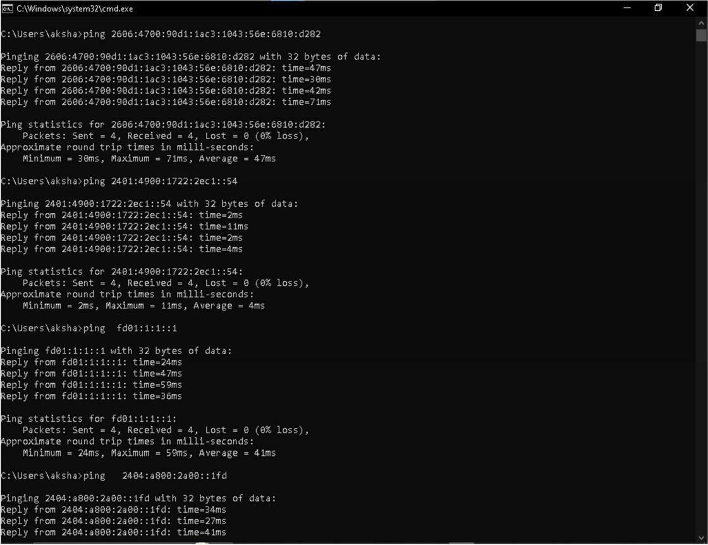

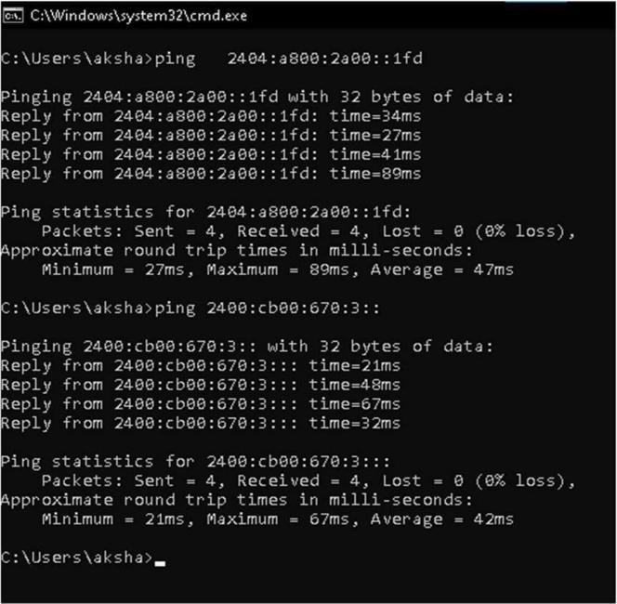

Step 3: Ipconfig
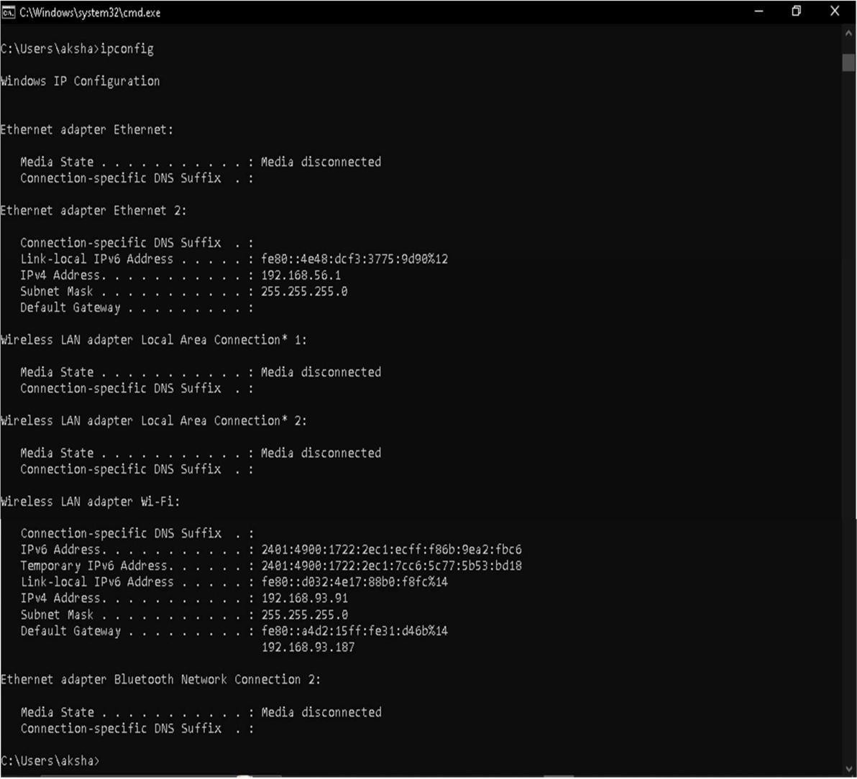

Step 4:Netstat
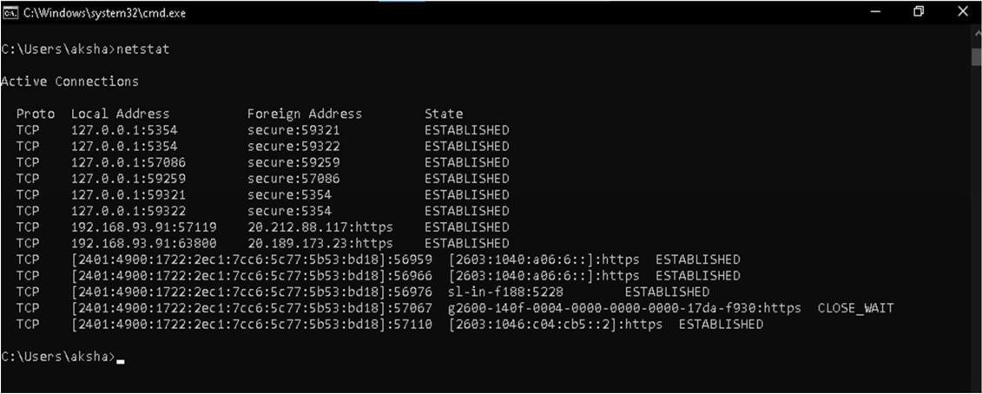

2) Perform ARP Poisoning in Windows

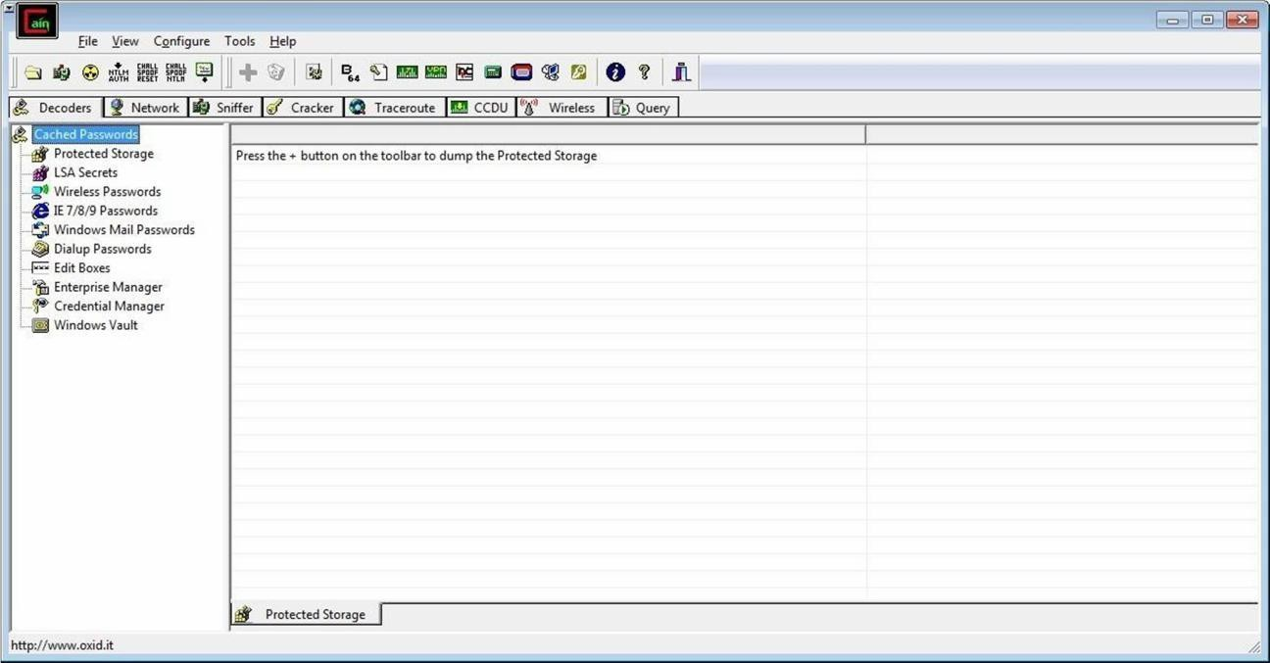

Step 2 : Select sniffer on the top.
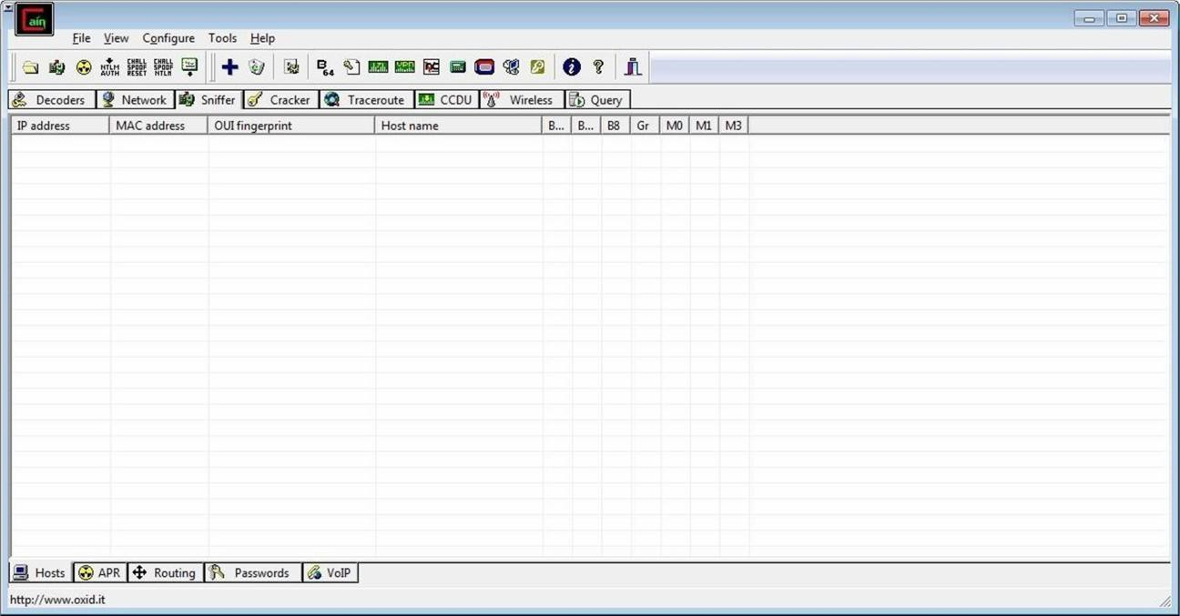

Step 3 : Next to folder icon click on icon name start/stop sniffer. Select device and click on ok.
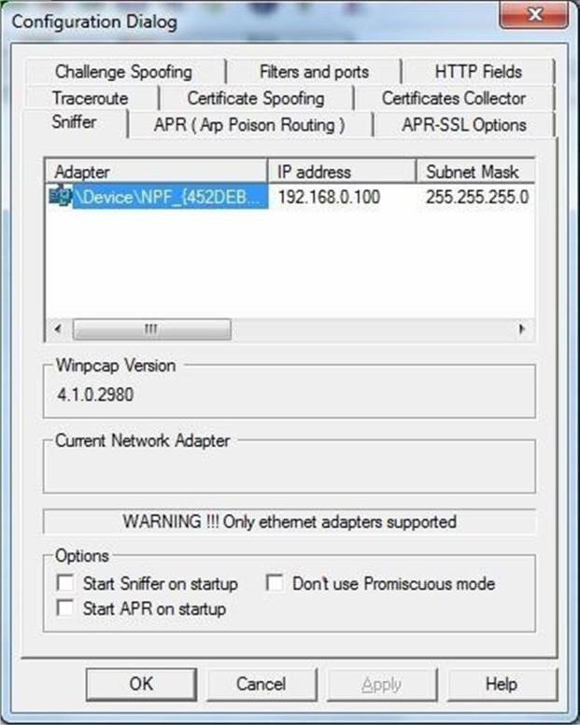

Step 4 : Click on “+” icon on the top. Click on ok.
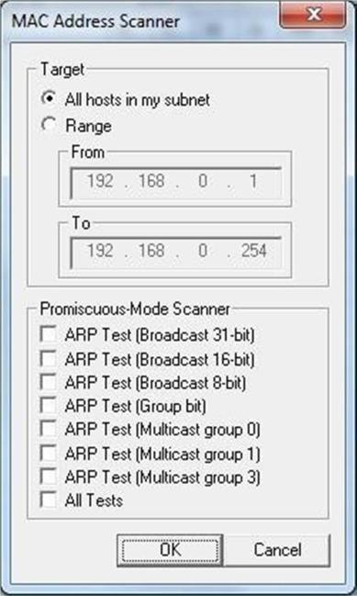

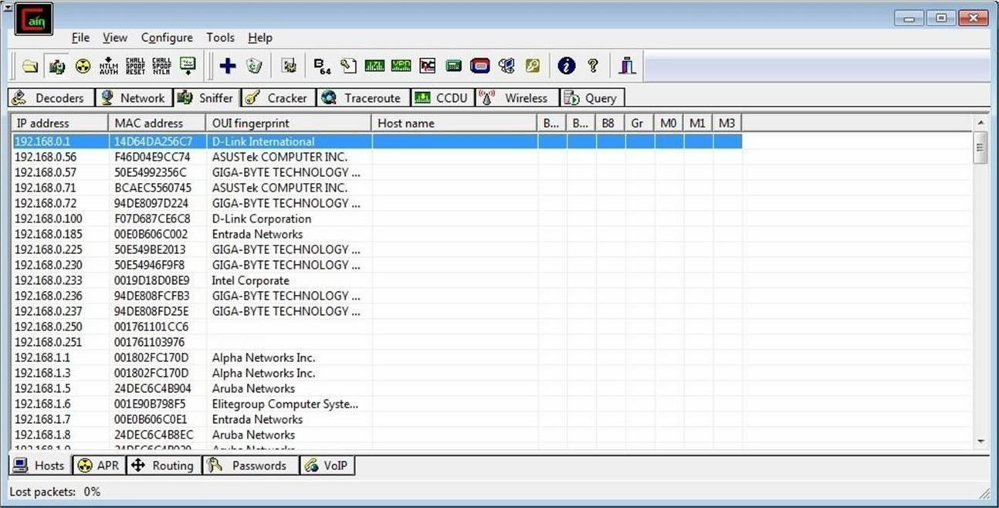
Step 5 : Shows the Connected host.

Step 6 : Select Arp at bottom.
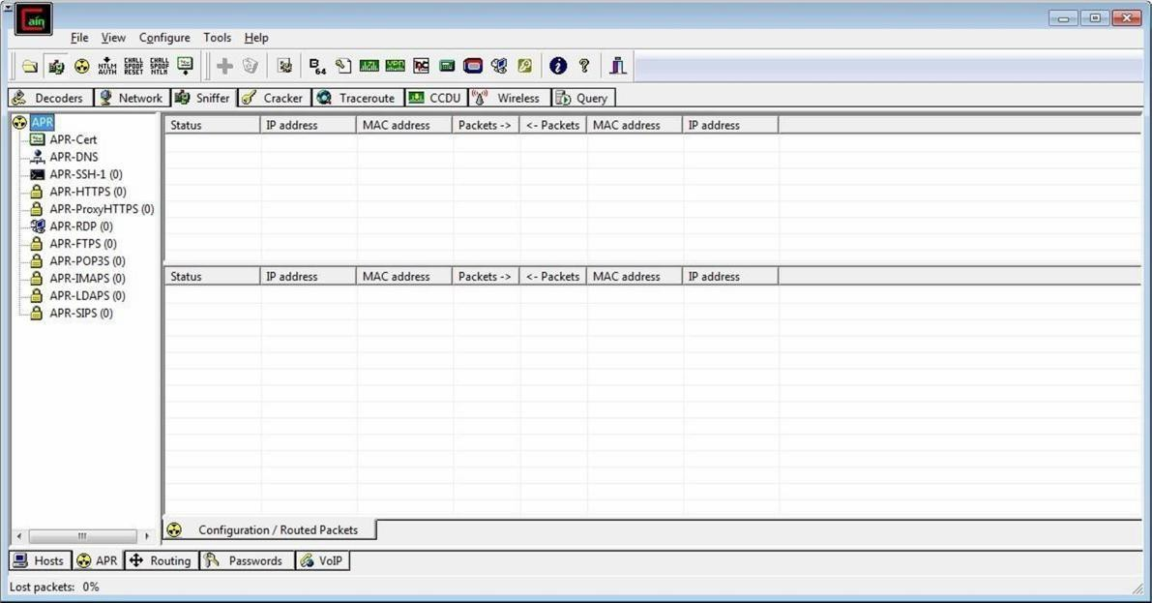

Step 7 : Click on “+” icon at the top.
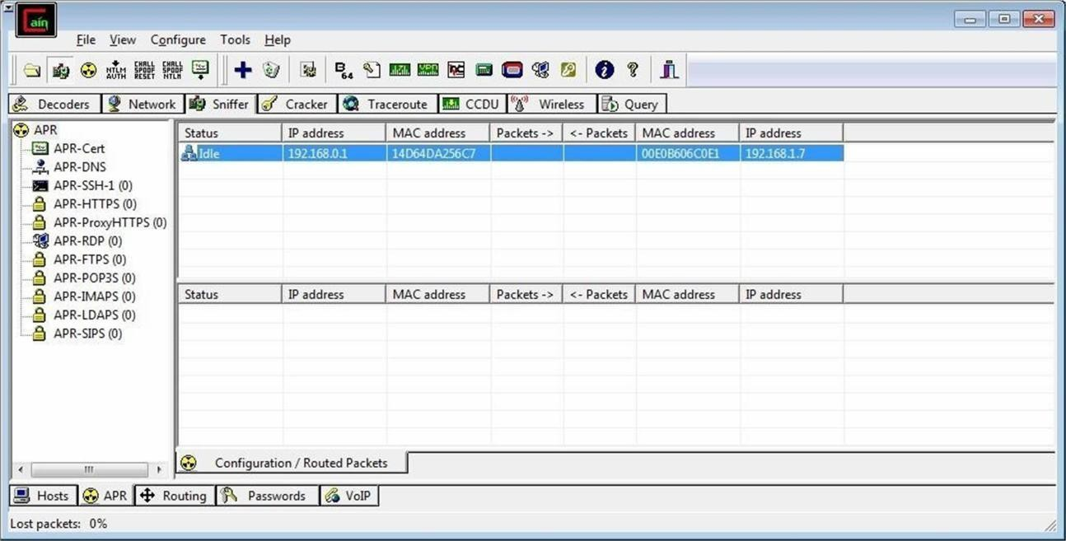

Step 8 : Click on start/stop ARP icon on top.

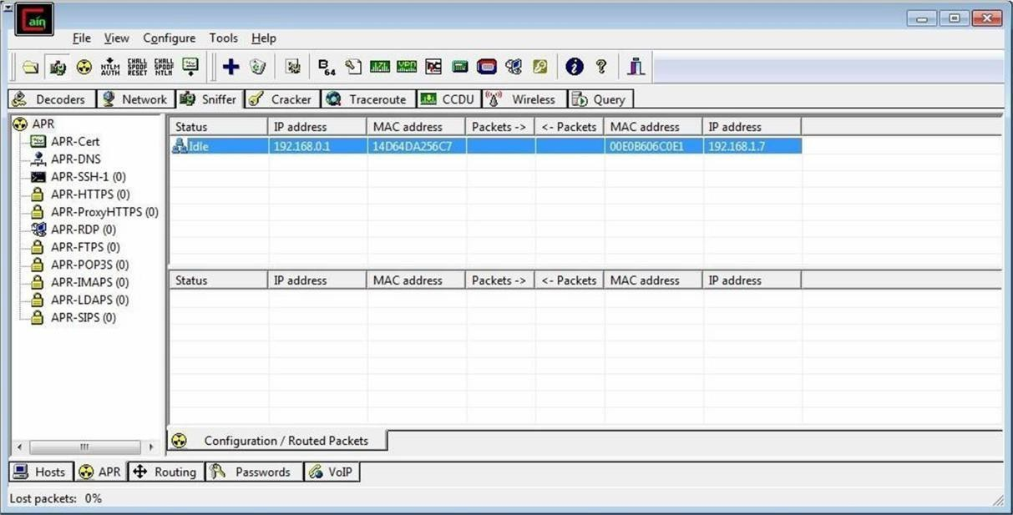

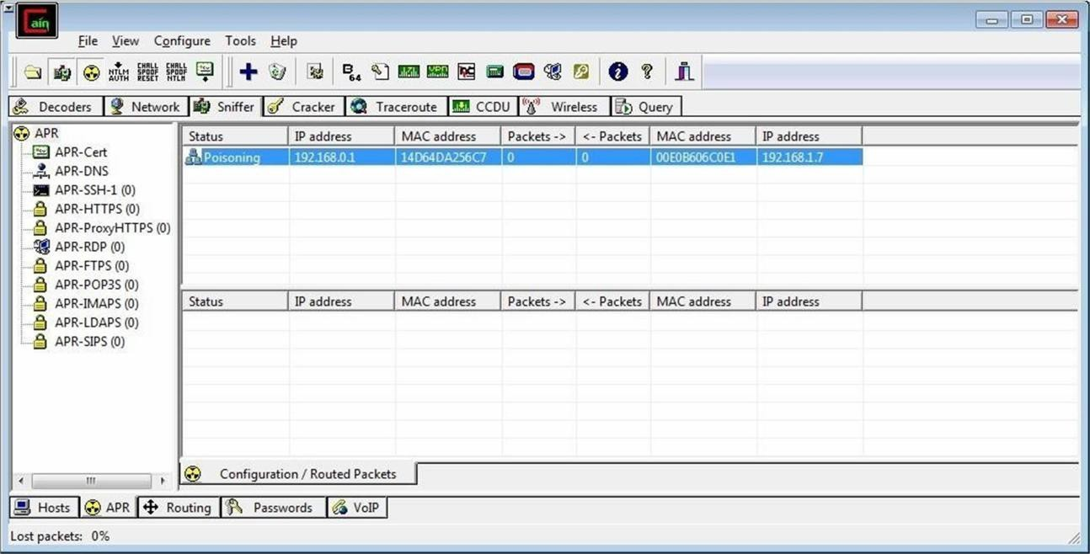
Step 9 : Poisoning the source.

Step 10 : Go to any website on source ip address.
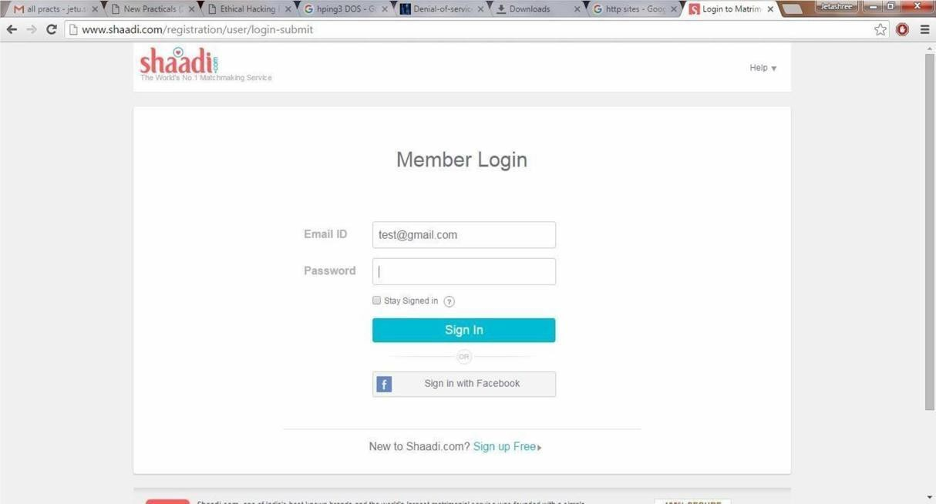

Step 11 : Go to password option in the cain & abel and see the visited site password.
